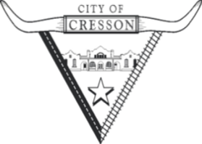

February 23, 2021

To All Cresson Residents:

If you are in need of any assistance due to the recent winter storm, there are several resources available to you.

[Home | disasterassistance.gov](https://www.disasterassistance.gov/)

FEMA programs do not pay for fuel or cover food losses. If you have immediate needs for food or shelter, you may contact 2-1-1 for local resources.

If you were affected by the winter storms in Texas, you can apply for disaster assistance online by selecting “Apply Online”. During the application process please ensure to select the cause of damage **snow/ice** amongst other damages that may have occurred.

Applicants are required to inform FEMA of all insurance coverage such as flood, homeowners, renter's, etc. that may be available to them. Insured applicants must provide FEMA documentation such as an insurance settlement or denial letter to process their application.

Thank you.